A centralized student help application for academics is a software application that aims to improve the overall user experience for students by providing a centralized location for accessing all of the resources students need in their academic pursuit. The importance of such an application lies in its ability to provide a one-stop-shop for students to easily access academic resources, such as class schedules, course materials, assignment submissions, and academic support services.
The purpose of this literature review chapter is to provide an in-depth analysis of the existing literature on centralized student help applications for academics. This review will focus on identifying the challenges faced by students in accessing academic resources, the various solutions proposed to address these challenges, and the best practices for designing and implementing an effective centralized student help application. By doing so, this literature review will provide valuable insights for the development of a centralized student help application for academics.

Research has shown that a centralized student help application can improve the overall user experience for students by providing a centralized location for accessing all of the resources they need. It can also reduce the burden on academic institutions by simplifying administrative tasks and improving communication between students and academic support services.
However, the effectiveness of a centralized student help application is dependent on various factors, including the design and usability of the platform, the availability and accessibility of resources, and the ease of integration with existing academic systems. These factors highlight the need for a comprehensive review of the existing literature to identify the best practices for developing a successful centralized student help application that addresses the needs and challenges of modern-day students.
Therefore, the literature review chapter will delve into the existing literature on centralized student help applications for academics, including their design, usability, and functionality, as well as the benefits and limitations of such applications. The review will also explore the various methodologies and approaches used in the development of centralized student help applications, highlighting the factors that contribute to their success or failure. The chapter will conclude with an analysis of the gaps in the literature and a discussion of the future research directions in this area.

Despite the benefits of EdTech platforms, the effectiveness of these platforms is dependent on several factors, including the quality and accuracy of the content, the user interface, and the ease of access and integration with existing academic systems. Therefore, a comprehensive literature review is necessary to identify the best practices in the design and development of EdTech platforms that address the needs and challenges of modern-day learners.
In this literature review, we will explore the existing literature on EdTech platforms, including their design, functionality, and effectiveness in enhancing student learning outcomes. We will also examine the different methodologies and approaches used in the development of EdTech platforms, highlighting the factors that contribute to their success or failure. Finally, we will analyze the gaps in the literature and identify future research directions in this area.

The current state of education is marked by rapid advances in technology and increasing demand for higher education. However, many students face a number of challenges that can hinder their success. One of the primary challenges is access to resources and support services. For example, students may struggle to navigate complex administrative processes or may lack access to high-quality academic support, such as tutoring or counseling.
This challenge can be particularly problematic for students who are new to the university or college environment, as they may be unfamiliar with the administrative processes and support services available to them. For example, students may not know how to access academic support services such as tutoring or writing assistance, or they may be unsure of how to navigate complex administrative processes such as financial aid or course registration.
This lack of access to resources and support services can have a significant impact on student success. For example, students who do not receive adequate academic support may struggle to keep up with course material or may experience difficulty with assignments and exams. Similarly, students who do not receive sufficient support with administrative processes such as financial aid may be unable to afford tuition or may face other financial barriers that prevent them from pursuing their education.
To address this challenge, there is a growing trend toward developing centralized student help applications that provide students with a single point of access to a wide range of resources and support services. These applications can help to streamline administrative processes and provide students with easy access to academic support services, financial aid information, and other resources that can help them succeed in their studies. In addition, many of these applications are designed to be mobile-friendly and accessible to students with disabilities, ensuring that all students have equal access to the resources and support they need to succeed in their academic pursuits.

Academic based student help applications as the name may imply are platforms, systems or software which have a variety of services which aim to aid students in their academics. These platforms today are what make up the education technology industry, they are also knows as edtech platforms. The history of student help applications can be traced back to the early 2000s when universities began to develop online learning management systems (LMS) to provide students with access to course materials, assignments, and communication tools. These early LMS systems were rudimentary and lacked the advanced features that are available today. However, they laid the foundation for the development of more sophisticated centralized student help applications.
Student help applications typically offer a variety of features to enhance the student learning experience. These may include access to course materials such as syllabi, readings, assignments, and multimedia content. They may also include features that enable students to collaborate with instructors and peers, such as discussion forums and video conferencing tools. Additionally, student help applications may provide access to support services such as academic advising, tutoring, and career counseling.
Numerous studies have identified the benefits of centralized student help applications for academics. For instance, Hsieh and Cho (2016) conducted a study on the use of a centralized mobile application for supporting learning activities in higher education. The study found that the use of a centralized mobile application led to improved student engagement, increased student participation, and better learning outcomes. The authors concluded that the use of mobile applications for education can promote more active and self-directed learning, and can provide a more personalized learning experience.Zhang et al. (2017) conducted a study on the effectiveness of a centralized student help application for distance learning. The study found that such an application can address many of the challenges that distance learners face. For instance, distance learners often experience isolation and lack of access to important course materials and support services. The study showed that a centralized help application can help overcome these challenges by providing students with access to course materials, communication with instructors and peers, and support services, such as tutoring and academic advising. Furthermore, the study found that a centralized help application can improve student engagement and participation. With features such as discussion forums, online quizzes, and group projects, students can interact with one another and feel more connected to their learning community.
Moreover, a study by Fang and Zhang (2015) found that a centralized student help application could help enhance student learning experiences, improve communication between instructors and students, and provide personalized learning experiences. The study also found that such applications could help institutions improve student retention rates and academic performance.
In conclusion, centralized student help applications have been shown to have significant benefits for both students and academic institutions. The application can help students access resources and support services more easily, improve learning outcomes, and enhance overall learning experiences. At the same time, academic institutions can use these systems to improve administrative efficiency, reduce costs, and provide better support to their students.

Moodle is an open-source learning management system (LMS) that is used by many educators and institutions around the world. It offers a range of features, including course management, collaborative tools, assessment tools, and content authoring. Moodle is highly customizable, and users can create their own plugins and themes to tailor the platform to their specific needs.
Despite its popularity, Moodle has some limitations and cons. One of the main drawbacks of Moodle is its steep learning curve. Because the platform is highly customizable, it can be difficult for new users to navigate and use effectively. Additionally, the platform's interface can be clunky and outdated compared to other modern LMSs.
Another limitation of Moodle is its lack of support for mobile devices. While the platform has a mobile app, it has limited functionality and can be frustrating for users who need to access course materials on-the-go. Additionally, Moodle's community-driven development model can sometimes result in inconsistent support and slow updates for certain features.
In conclusion, while Moodle offers many powerful features and benefits, it is not without its limitations and cons. Educators and institutions should carefully consider their specific needs and requirements when choosing an LMS, and weigh the pros and cons of Moodle against other options in the market.
One of the key advantages of Moodle is its flexibility, which allows for a wide range of teaching and learning styles. Moodle supports a variety of pedagogical approaches, such as blended learning, flipped classroom, and project-based learning. It also supports various types of assessments, including quizzes, assignments, and peer assessments.
In addition to its flexibility, Moodle is also known for its strong community support. Being an open-source platform, Moodle has a large and active community of developers, educators, and users who contribute to the development and improvement of the platform. The Moodle community provides a wealth of resources, including documentation, user forums, and plugins.
However, like any platform, Moodle has its limitations and drawbacks. One of the main limitations is that Moodle can be challenging to set up and maintain, especially for users who are not familiar with server administration and programming. Another limitation is that Moodle's user interface can be somewhat outdated and clunky, which can make it less appealing to some users.
Furthermore, some users have also raised concerns about the security and privacy of Moodle, particularly with regards to the storage of personal data and user information. There have been several reports of data breaches and security vulnerabilities in Moodle over the years, which have raised concerns among educators and administrators.
Overall, while Moodle is a powerful and flexible LMS that offers a wide range of features and benefits, it is important for users to carefully consider its limitations and drawbacks before adopting it as their primary learning platform.

TutorMe's platform includes a virtual whiteboard, screen sharing, and video and audio chat, making it easy for tutors and students to collaborate in real-time.

Research on learning management systems (LMS) has explored the effectiveness of various LMS features and tools on student learning outcomes and engagement. However, there is still a need for further research to determine which LMS features are most effective in improving student learning outcomes and engagement.
One area that requires further research is the effectiveness of social learning features in LMSs. Social learning features such as discussion forums and group projects are designed to encourage collaboration and knowledge sharing among students. While some studies have found these features to be effective in improving student learning outcomes and engagement, other studies have found mixed results. Further research is needed to determine how social learning features can be optimized for maximum effectiveness.
Another area that requires further research is the use of analytics and data-driven decision-making in LMSs. LMSs are capable of generating large amounts of data on student performance, engagement, and behavior. However, there is a need for further research to determine how this data can be effectively used to improve student learning outcomes and engagement.
Furthermore, there is a need for research on the effectiveness of different instructional design strategies within LMSs. For example, research could investigate the impact of using multimedia content, interactive simulations, and personalized feedback on student learning outcomes and engagement.
In addition, there is a need for research on the effectiveness of LMSs for different student populations, such as non-traditional students, students with disabilities, and students from diverse cultural backgrounds. This research could investigate how LMSs can be customized to meet the unique learning needs and preferences of these student populations.

As the use of LMSs becomes more widespread in education, there are potential ethical and privacy concerns that should be considered. One potential concern is the collection and use of student data by the LMS provider. This data may include personally identifiable information, as well as data related to student performance and behavior in the LMS.
There are also concerns related to the security of student data and the potential for data breaches or unauthorized access. LMS providers must take steps to ensure the security and privacy of student data, such as implementing strong authentication protocols and data encryption.
Another ethical concern is the potential for LMSs to perpetuate social inequalities, as some students may not have equal access to technology or the internet. This could result in a disadvantage for these students, who may be unable to fully participate in online learning activities.
Furthermore, the use of LMSs may raise questions about academic integrity, as some LMSs may allow for easy sharing of information or collaboration among students. This could lead to concerns about plagiarism and cheating, which may need to be addressed through the implementation of policies and procedures to prevent academic dishonesty.

Investigating the role of student help applications in promoting student collaboration and social learning. Analyzing the impact of student help application implementation on instructor workload and student workload. Exploring the potential of student help applications to support personalized learning and adaptive learning. Investigating the impact of student help applications use on student motivation and satisfaction with their learning experience. Analyzing the use of student help applications in different educational contexts and cultures, including K-12 and higher education, and international settings.

Centralized student help applications or EdTech platforms have a variety of services that aim to aid students in their academics, including access to course materials, support services, and communication tools. The benefits of these platforms include improved student engagement, increased participation, better learning outcomes, and improved access to resources and support services. However, studies have also highlighted potential limitations such as complexity, lack of user-friendliness, and overwhelming information.

Centralized student help applications, also known as edtech platforms or learning management systems (LMS), offer a variety of features to enhance the student learning experience. These features may include access to course materials, collaboration tools, and support services such as academic advising and tutoring. Numerous studies have identified the benefits of centralized student help applications for academics, including improved student engagement, participation, and learning outcomes. However, potential limitations of LMSs have also been identified, such as complexity and lack of user-friendliness. Future research could examine the effectiveness of different student help application features on student learning outcomes and engagement, and the use of analytics and data-driven decision-making in these systems.

Centralized student help applications, or edtech platforms, have become increasingly popular in recent years due to their potential to enhance the student learning experience. These applications typically offer a wide range of features, including access to course materials, collaboration tools, and support services such as academic advising and tutoring.
Numerous studies have identified the benefits of these platforms for academics. For example, they have been found to improve student engagement, participation, and learning outcomes. Students may also benefit from the increased flexibility and convenience offered by these systems, as they can access course materials and support services from anywhere with an internet connection.
However, potential limitations of LMSs have also been identified. For example, they can be complex and may not be user-friendly for all students. Additionally, some students may prefer more traditional methods of learning or may struggle with technology, which could impact their ability to benefit from these platforms.
Future research could explore the effectiveness of different student help application features on student learning outcomes and engagement. It could also investigate the use of analytics and data-driven decision-making in these systems to provide more personalized support for students. Overall, centralized student help applications have the potential to significantly enhance the student learning experience, but it is important to consider the limitations and to continually assess and improve these systems.
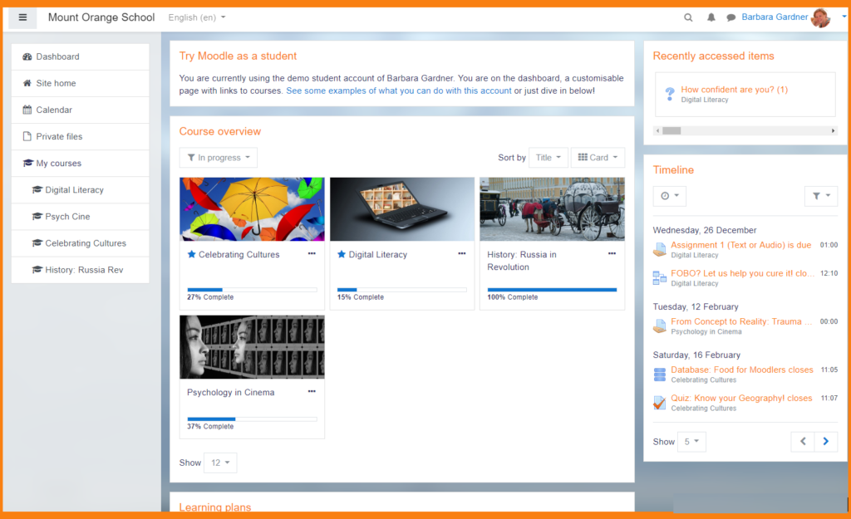
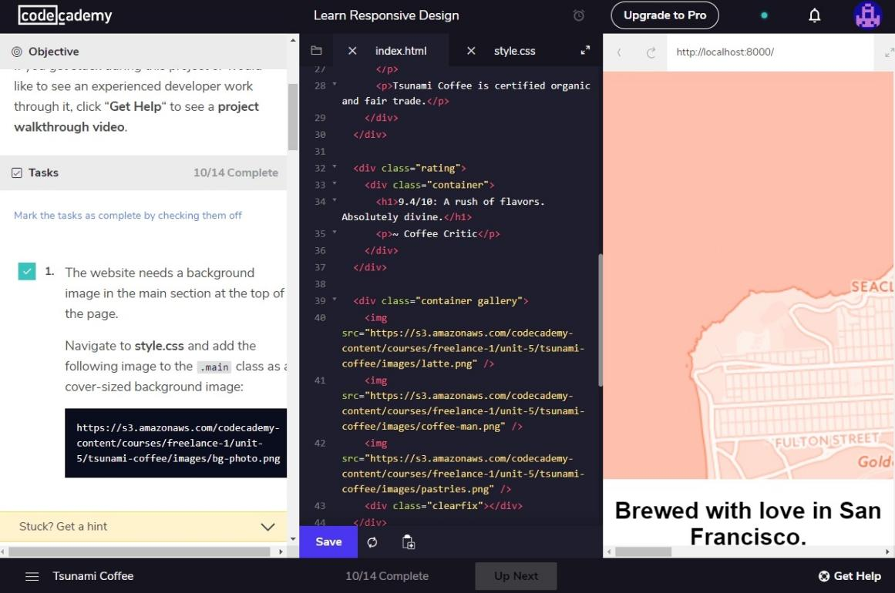

Sure, I can provide a general plan for creating a student help application with some suggested features and steps to achieve them. Please note that this plan is just a starting point, and the actual plan will depend on various factors, such as the target audience, the scope of the application, and the available resources.
Features:
Course materials management
Communication and collaboration tools
Academic advising and counseling
Tutoring services
Progress tracking and reporting
Section 1: Course Materials Management Steps:
Design a user-friendly interface for accessing course materials.
Develop a discussion board for asynchronous communication between students and instructors.
Implement a notification system to keep users updated about important events and deadlines.
Create a calendar feature to help users keep track of their schedule and deadlines.
Integrate video conferencing software for virtual office hours or online class sessions.
Section 3: Academic Advising and Counseling Steps:
Develop a system for scheduling appointments with advisors and counselors.
Implement a chat or video conferencing system for remote advising and counseling.
Create a database to store student profiles, academic plans, and progress.
Implement an automated alert system to notify advisors and counselors of potential issues such as poor performance or missed deadlines.
Integrate the advising and counseling system with the progress tracking and reporting system.
Section 4: Tutoring Services Steps:
Design a database to store tutor profiles, subject areas, availability, and feedback.
Implement a system for scheduling appointments with tutors.
Integrate a chat or video conferencing system for remote tutoring.
Develop a payment and billing system for paid tutoring services.
Integrate the tutoring system with the progress tracking and reporting system.
Section 5: Progress Tracking and Reporting Steps:
Develop a system for tracking student progress, such as grades, attendance, and participation.
Implement a dashboard for students to view their progress and performance.
Create reports for instructors, advisors, and counselors to review student progress.
Develop an analytics system to identify trends and patterns in student performance.
Integrate the progress tracking and reporting system with the other sections of the student help application.
Overall, this is just a general plan, and there are many more details that need to be fleshed out for each section. Additionally, there may be other features or sections that could be added depending on the specific needs and goals of the student help application.

